Hoard

By Ace English and Josh Kelso-Lamb

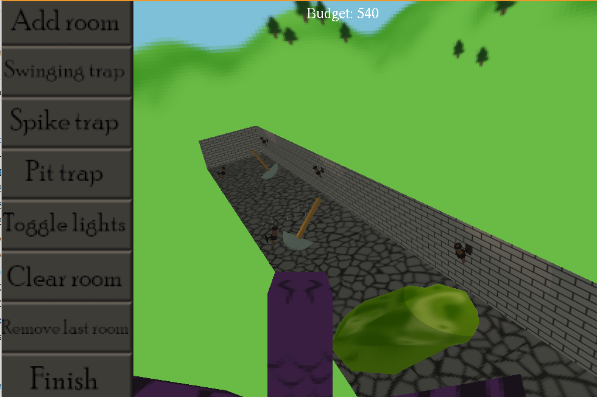

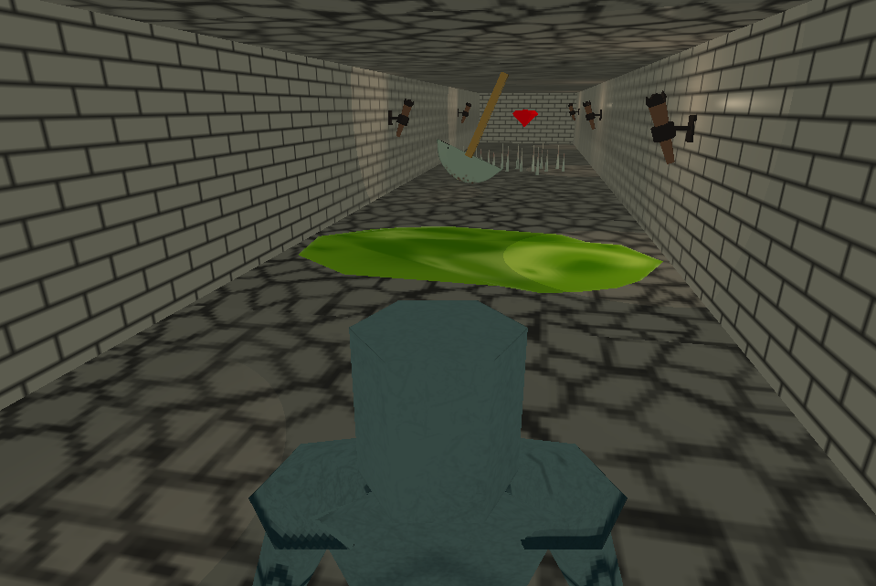

# How to run

Run compile.batch, then run.batch.

To play online, first run server.batch. Then, in the command line type “java -Dsun.java2d.d3d=false -Djava.library.path="C:\javagaming\jinput\lib" a1.MyGame [ip] [port] [true/false]

Command line arguments include

1. the ip of the server you’d like to try connecting to

2. the port on which to connect to that ip

3. true for fullscreen or false for windowed mode. Windowed mode is reccomended.

# Special Requirements

Must use a mouse and either a keyboard or controller to play as the dragon. Knight can play on either keyboard or controller. Character selection is done via mouse.

# How to play

The knight waits for the dragon to set up their lair. The dragon has multiple rooms with which to defend their hoard, and can spend some of their gold to purchase traps and rooms. When the dragon is ready, the knight will teleport into the lair and now must try get to the hoard.

The dragon should try to stop the knight while spending as little of his hoard as possible to achieve a higher score.

### Controls

**Knight:** WASD to move, arrow keys to look around. Space to jump. Escape disconnects from the server.

Controller: Button 0 or “A” to jump. Bumpers to rotate camera. Triggers to zoom camera in/out. Left joystick to move. Right joystick to look around.

**Dragon:** WASD to move. Arrow keys affect pitch and yaw. Q and E control roll. Space to roar. Lair building can be done using the mouse UI

Controller: Left joystick to move. Right joystick to affect pitch and yaw.

# Requirements Met

**Blendered Models:** knight, dragon, torches, pit trap, swinging axes, spike trap

**Networked Multiplayer:** Thin-client

**Scripting:** In single player mode, the dungeon will randomly generate for the knight to navigate if the human player chooses to play knight. Written in javascript.

**Skybox and terrain:** outside of lair. While waiting for the dragon the knight can kick around a ball on the terrain.

**Lights:** in some dungeon rooms. Dragon can turn them off if desired. Ambient light also implemented.

**3D sound:** ambient music for set up and a different song for raiding. The dragon can roar to psych the knight out.

**HUD:** Dragon has a hud for base set up.

**Hierarchical Scenegraph:** rooms are built as node groups which are connected to a larger dungeon parent nodegroup. Traps and torches also exist as child nodes.

**Animation:** knight walking, dragon flapping wings

**NPC:** On single-player mode, the computer plays the knight if the human player chooses to play dragon.

**Physics:** knight can jump. Traps use collision detection and physics calculation for motion. Balls in waiting area use physics.

# Additional Documentation

# KNOWN Issues

* Skeletal models cause RAGE to crash when exiting. This is believed to be due to bad engine code
* Traps may not move in sync in multiplayer mode
* HUD not designed for FSEM

# Assets

* Floor, wall, gem, knight, dragon, torch, trap and skybox textures made by Ace.
* Knight, traps, and torch models made by Ace
* Dragon model made by Josh
* Terrain maps made by Josh
* Music from https://filmmusic.io:

"Klockworx" and “EDM Detection Mode” by Kevin MacLeod (https://incompetech.com)

Licence: CC BY (<http://creativecommons.org/licenses/by/4.0/>)

* Dragon roar sound effect by user frasbr on freesound.org <https://freesound.org/people/frasbr/sounds/145729/>

Licence: CC BY (<https://creativecommons.org/publicdomain/zero/1.0/>)